**WriteUp**

1. Create spring maven project “UserManager”
2. Include dependencies : spring web, devtools, mysql driver.
3. Create following class with package
4. 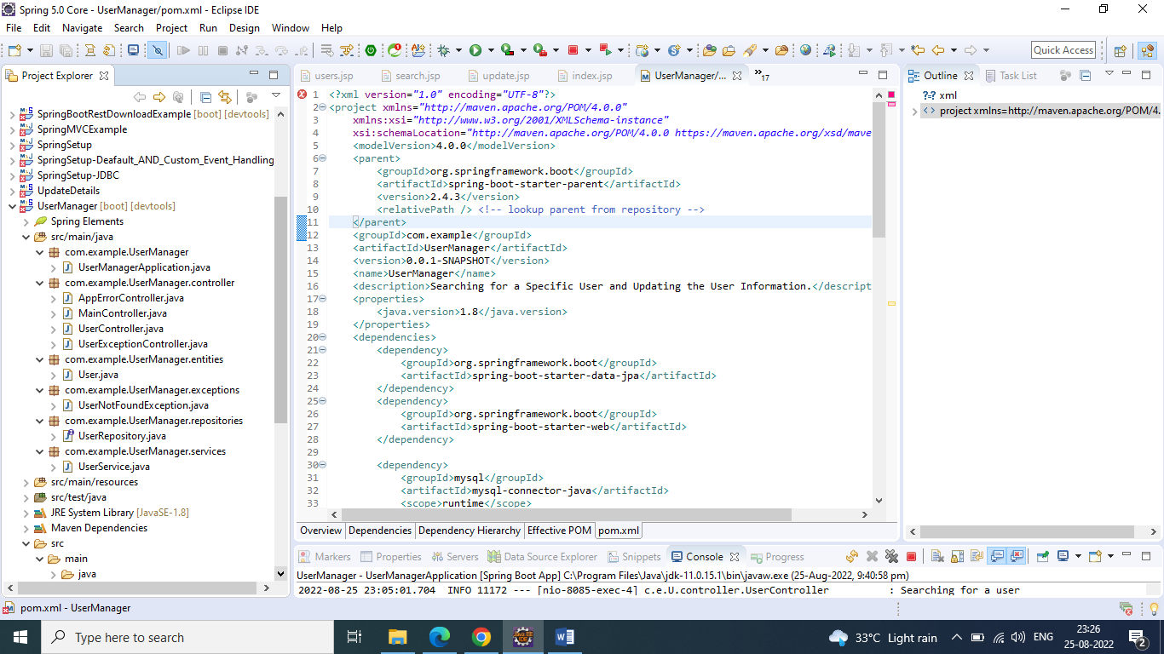
5. User.java contains id, name, email, password fields with annotation.
6. UserManagerApplication is main class.
7. UserController Contain methods for system.
8. Create a folder “jsp: in WEB-INF, which contains all jsp files.
9. 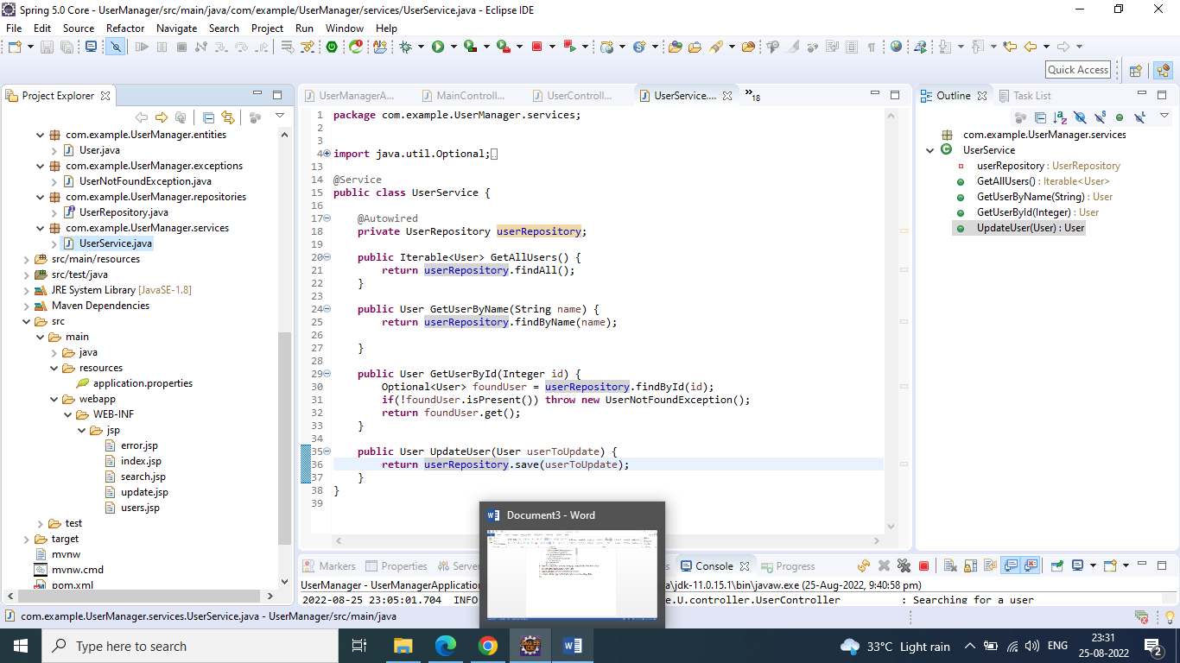
10. Index.jsp is home page.
11. Search.jsp contains user information search by id and editable form.
12. Update.jsp is displaying updated information af a user.
13. Users.jsp is displaying detail of all users.